What was changed in these Scratch cards

# Source

All cards were taken from

<https://github.com/LLK/scratch-resources/tree/master/resources/source/cards/Powerpoint-files>

When trying to translate the cards, I concluded that there were quite some issues that would better by corrected for all languages. That is what has been done with the Scratch cards in this folder.

# Issue 1: Center alignment by setting the indentation

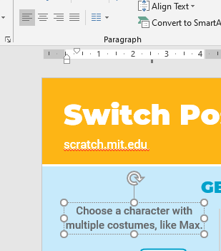Example of original text:

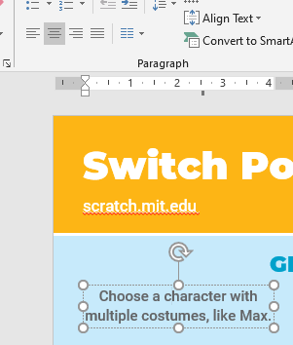Tekst looks centered, but it is using an indentation. Changed into:

# Issue 2: Two lines in a single box

Example of original text:

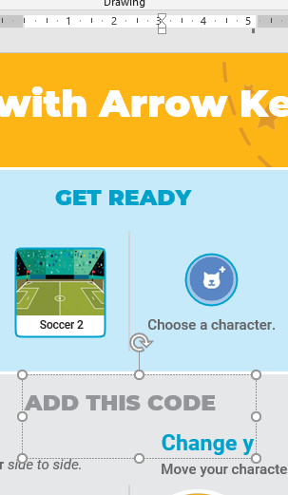

The lines with ADD THIS CODE and Change y are in the same box. That is not handy if one has to be moved or to be centered in different way. Such boxes are split into two separate boxes.

# Issue 3: Text boxes too narrow for translation

Some of the text boxes just fit the English text, but when translated text is longer then the box starts wrapping while there is sufficient room left and/or right. Those boxes were widened.

# Issue 4: Resolution

All resolutions have been set to the maximum, to not compress images and to print with high fidelity.

# Issue 5: Icons with low resolution and wrong colour

Some of the files have icons with low resolution and they also have the wrong blue color. Some are also have a circle around them that is not well centred. New icons have been put in everywhere there was that problem spotted.



# Issue 6: Bleed

When the cards have to be printed then bleed needs to be added since the colours run to the edge. Bleed has NOT been added in this set of cards, but for that see the set of cards in an adjacent folder.

# Issue 7: No version indication

There is no version indication on the cards, so when printed and a new version comes, the old and new version can be easily mixed up. In this set of cards, NO version has been added. For that, see the set of cards in the adjacent folder.